English Grammar for 6-8 Year Olds

Level: Beginner

Nouns
Definition: Nouns are words that name people, places, animals, or things! Think of them as labels for everything around you
Example: The dog is playing in the park.

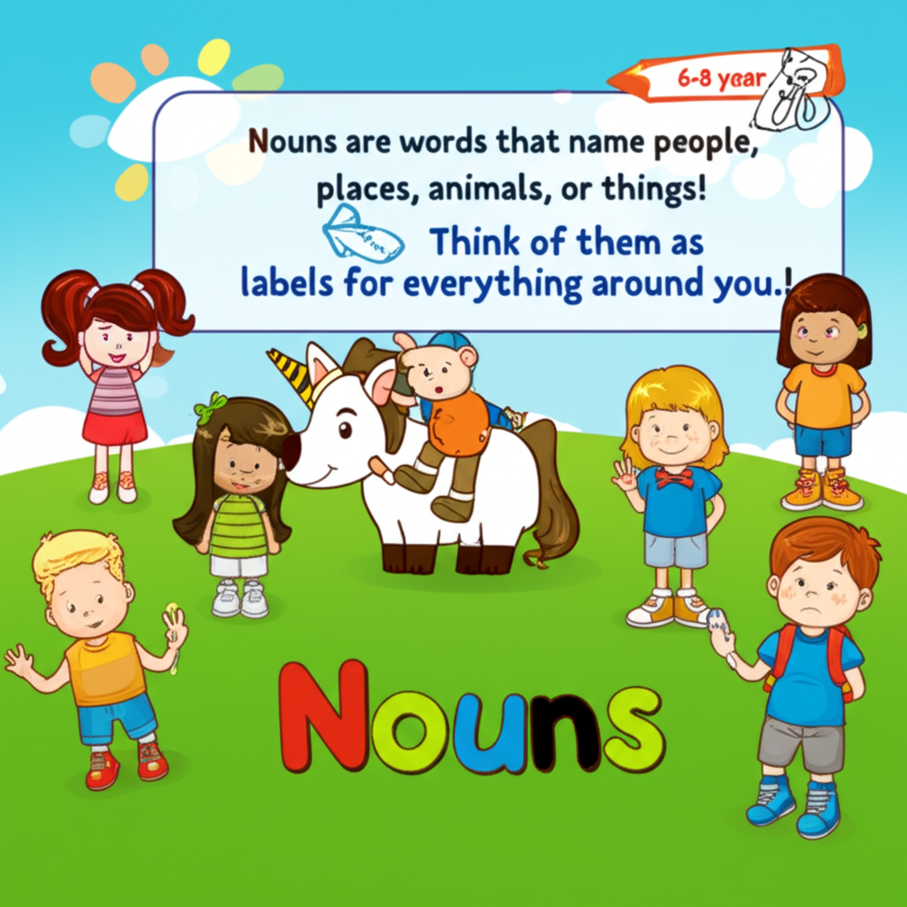
Nouns

Verbs
Definition: Verbs are action words! They tell us what someone or something is doing
Example: The bird sings a pretty song.

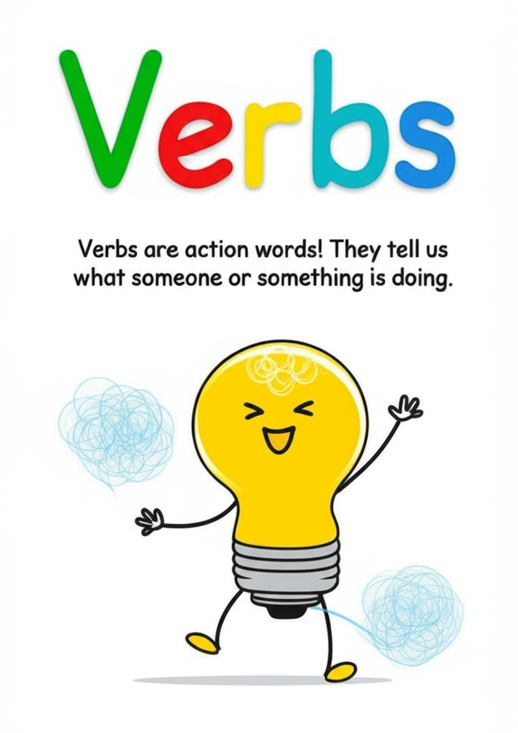
Verbs

Adjectives
Definition: Adjectives are words that describe nouns
Example: The big ball is red.

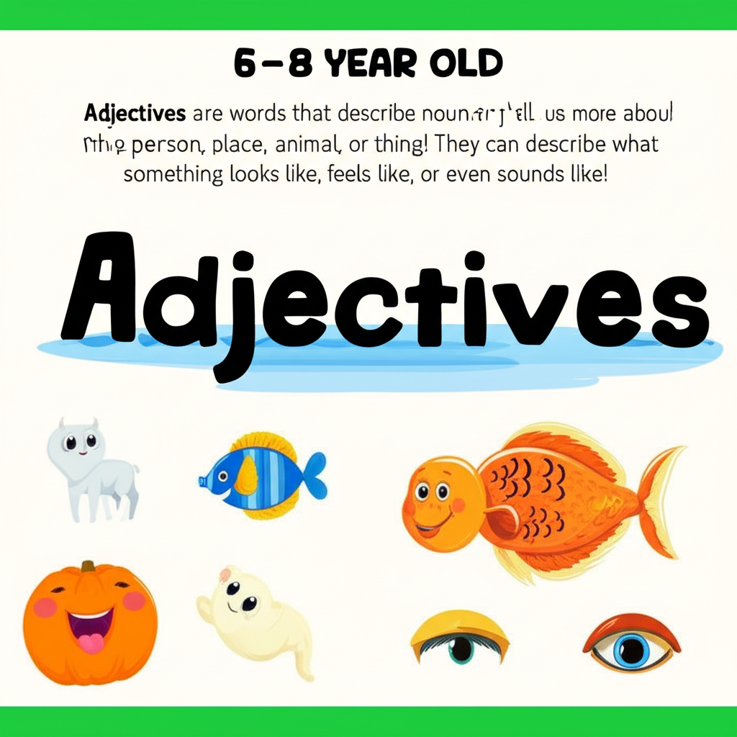
Adjectives

A or An
Definition: We use "a" before words that start with a consonant sound (like b, c, d, f, g)
Example: I saw a cat." "I ate an apple.

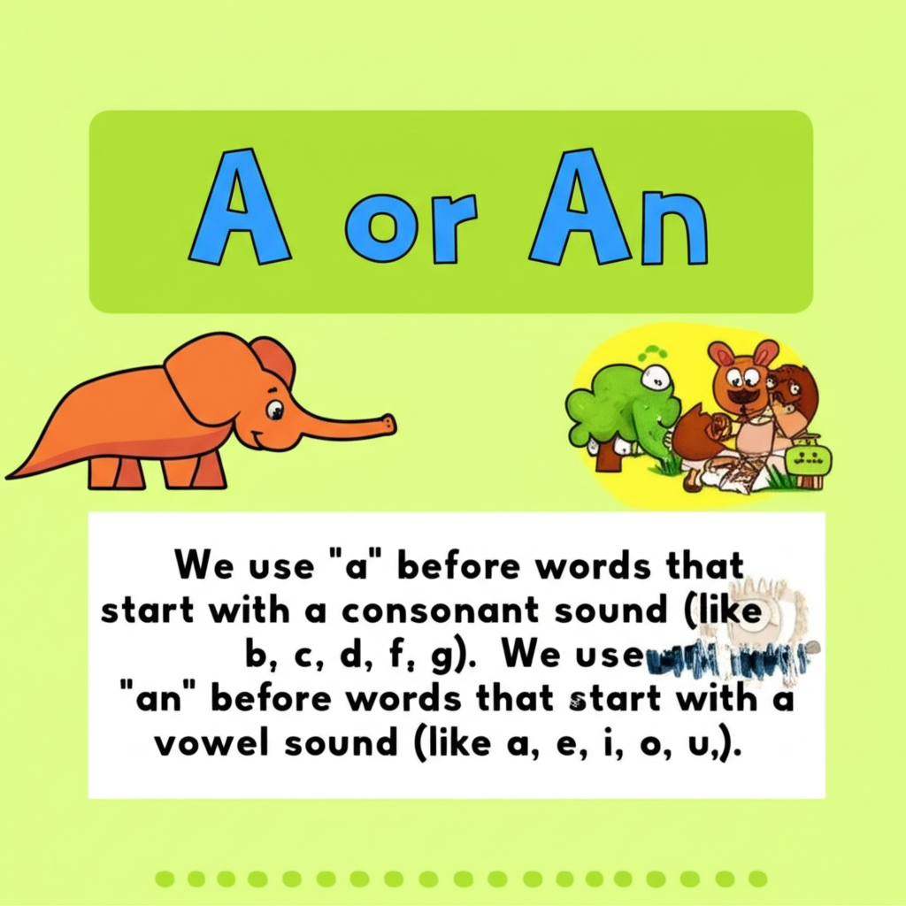
A or An

Practice Activities
1. Noun Hunt: Look around the room and find five nouns. Write them down or draw pictures of them.
2. Action Time: Act out different verbs, like jumping, singing, or reading. Can you guess what verb your friend is acting out?
3. Describe It: Find an object and think of three adjectives to describe it. For example, a teddy bear could be fluffy, brown, and cuddly.
4. "A" or "An" Game: I'll say a word, and you tell me if it needs "a" or "an" before it. (Examples: elephant, book, orange, table)
## Fun Exercises
1. Silly Sentence Maker: Write down a list of nouns, verbs, and adjectives. Then, pick one from each list to create a silly sentence! For example: "The fluffy dog sings loudly."
2. Drawing Challenge: I'll give you a sentence with an adjective and a noun. You draw a picture of what the sentence describes. For example: "The yellow sun."

